**Amazon AppStore**

Game Design Notebook

How to use this book?

Bringing a game to life is about more than great ideas and awesome coding skills. That’s why we created this Game Design Notebook to help guide you through the process of getting your game ready for development.

By following the step throughout this notebook, you’ll end up with a focused game concept and design. From working out the gameplay and visuals, to target audiences and frameworks, documenting your game will make building it easier and more fun. Let’s start designing!

--- Jasse Freeman

Thank you for Amazon providing such useful game design notebook to the game developers, especially useful to the students who start to learn how to make a game in school.

by Dr. Chi-Hsiung Liang

Department of Multimedia and Game Science

Lunghwa University of Science and Technology, Taiwan.

Table of contents

Summarize Your Game 3

Gameplat 4

Design your game 5

Build your game 6

Resources 6

Publish your game 8

## Summarize Your Game

**遊戲概要**

Completing this section will give you a starting point for the development process by refining your game’s concept.

結束本單元將為您提供開發過程的起點，透過改進對遊戲的概念，

**Name your game**

**為您的遊戲命名**

Clear, descriptive, easy –to-remember titles tend to perform best. What are three possible names for your game?

清晰，描述性強，易於記憶的標題往往表現最佳。

你的遊戲有三種可能的名字？

1. _______________________狗狗大冒險________________________
2. _______________________狗狗奇遇記________________________
3. _______________________狗狗歷險記________________________

**Build your team**

建立你的團隊

The right team is almost as important as the game idea itself. They will execute on your vision and make your game as awesome as it deserves to be. Who is on your team?

正確的團隊幾乎和遊戲理念本身一樣重要。他們會執行你的願景，並使你的遊戲真棒，因為它是值得的。誰在你的團隊中？

|  |  |  |
| --- | --- | --- |
| Name名稱 | Role 角色 | Contact 聯繫 |
| 劉宥良 | 汪 | 0917627451 |
| 張峻逸 |  | 0975081370 |
| 郭益豪 |  | 0987654321 |
| 陳泓偉 |  | 0912345678 |
|  |  |  |
|  |  |  |

**Your Pitch (你的精要的遊戲介紹)**

Also known as the Elevator Pitch, this is a single sentence that gets other people excited about your game. What is your game about?

也稱為電梯簡報，這是一句話，讓人們對你的遊戲感到興奮。簡單扼要名你的遊戲是關於什麼的？

這款遊戲是針對3-6歲的小孩來做設計,是關於尋找動物的遊戲

**Your game’s features**

**您的遊戲功能**

What will get players excited about your game?

Which stand out elements would you put on the back of the box?

什麼會讓玩家對你的遊戲感到興奮？

你會把哪些元素放在盒子的背面？

可愛動物遊戲

**Your Game’s theme**

**你的遊戲的主題**

What is the overall theme that your game revolves around? If you’re at a game jam, you’re lucky’ just copy the jam’s theme here.

遊戲圍繞著什麼總體主題？如果你曾經參加過遊戲製作馬拉松(Game Jam)，那麼你很幸運，就是在這裡複製Game Jam的主題。

尋找更多狗狗

**Your target audience**

**您的目標玩家**

Who do you want to play your game? What do they like? How will your game appeal to them? Choosing your target audience will help you focus your game.

誰想玩你的遊戲？他們喜歡什麼？你的遊戲如何吸引他們？選擇你的目標玩家將有助於你專注於你的遊戲。

3-6歲的小孩

用可愛的動物 來吸引他們

## Game play

**遊戲玩法**

This is the blueprint for your game.

Using the previous section as inspiration, describe your game in as much detail as possible. How will it be played? What does if look like? What makes it unique?

What kin d of experience do you want the player to have? Outline the objective, and summarize how a player wins.

這是你遊戲的藍圖。 使用上一節作為靈感，盡可能詳細地描述您的遊戲。它將如何發揮？如果看起來像什麼？是什麼使它獨一無二？ 你想要玩家擁有什麼經驗？概述目標，並總結玩家如何獲勝。

There are a few things to keep in mind while you document the various parts of your game: scope, development time and hardware limitations. Write down everything. Even if something is too difficult to build now, it might be possible later and you won’t want to forget any of your ideas.

Finally, be realistic about your development timeline, especially if you’re at a game jam.

在記錄遊戲的各個部分時，請記住以下幾點：範圍，開發時間和硬體限制。寫下一切。即使現在有些東西太難建立，以後可能也會有可能，你不會想要忘記你的任何想法。

最後，對你的開發時間表保持現實態度，特別是當你參加製作馬拉松遊戲時。

Most at all, have fun! This is where your whole vision comes together and you create a map to build from.

最重要的是，玩得開心！這是您的所有願景聚集在一起的地方，您可以創建一個藍圖來建立。

## Design your game

**設計你的遊戲**

What does your game look like? Show off everything from your main character and the world around them, to the inventory screens, dialog boxes and User Interface (UI). Visuals go a long way to making your game a reality.

Sketch out how you want your game to look and feel.

你的遊戲是什麼樣的？展示主角和周圍世界的所有內容，螢幕清單，對話框和用戶界面（UI）。視覺效果可以讓你的遊戲變為現實。 勾勒出你希望遊戲的外觀和感覺。

If you are looking to draw game screens or break the grid up into boxes, you can connect the darker dots on each page to create 1, 2 or 4 boxes to draw in.

如果您想繪製遊戲螢幕或將網格分成多個框，可以在每個頁面上連接較暗的點以創建1個，2個或4個框來繪製。

## Build your game

**建立你的遊戲**

The previous section should give you a clear idea of the game you want to build and the way it will look. Now it’s time to make it!

上一節應該給你一個你想要構建的遊戲和它看起來的方式的清晰概念。現在是時候來做了！

**Pick a framework**

選擇一個框架

A game framework can help speed up the development process. Here are some of our favorites.

遊戲框架可以幫助加快開發進程。這裡有一些我們的喜愛的項目。

|  |  |  |
| --- | --- | --- |
| **Name** | Level | Language |
| Game maker V2 | Beginner | GML |
| Corona 2D | Beginner | lua |
| Unity 3D | Intermediate | C# & JS |
| Cocos 2D | Experienced | C++ |
|  |  |  |

**Set your milestones**

**設定你的計劃的里程碑**

A milestone marks a major development event like vertical slice, first playable or alpha. Create a high-level schedule for your game.   
計劃著垂直切片，首次播放或alpha等重大發展事件。為您的遊戲創建進階的 計劃表。

|  |  |
| --- | --- |
| Milestone | Date |
|  |  |
|  |  |
|  |  |

## Resources

**資源**

|  |
| --- |
| Presskit()  depresskit.com  beautiful, optimized and efficient press pages in 30-60 minutes.  美觀，優化和有效的30-60分鐘內的新聞稿。 |
| **Pomodoro Technique**  bit/;u/2vHjd14  A popular time management method developed in the late 1980s  在1980年代後期開發的一種流行的時間管理方法 |
| **level up! The guide to great video game design.**  amzn.to/2hEIR2c  A must-read book on game design  一本關於遊戲設計的必讀書籍 |
| **Game assets on open game art**  bit.ly/2hDy16B  Game sprites, backgrounds, and more.  遊戲精靈，背景等等。 |
| **Getting started making games**  amzn.to/2vdGpTH  Helpful advice from documenting your idea through launch.  通過啟動記錄您的想法提供有用的建議。 |
| **Developer’s Guide to the Amazon appstore**  Bit.ly/2vqqQtq  Publishing, promoting, and making money with your app.  使用您的應用發佈，宣傳和賺錢。 |
|  |
|  |

**Create your icon**

**創建你的遊戲圖標**

Before you release your game, you’ll need an icon. Sketch out your ideas.

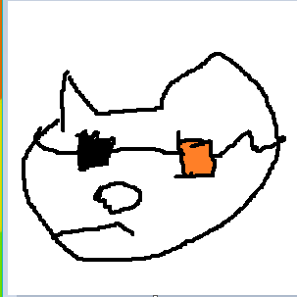在你發佈你的遊戲之前，你需要一個圖標。勾畫出你的想法。



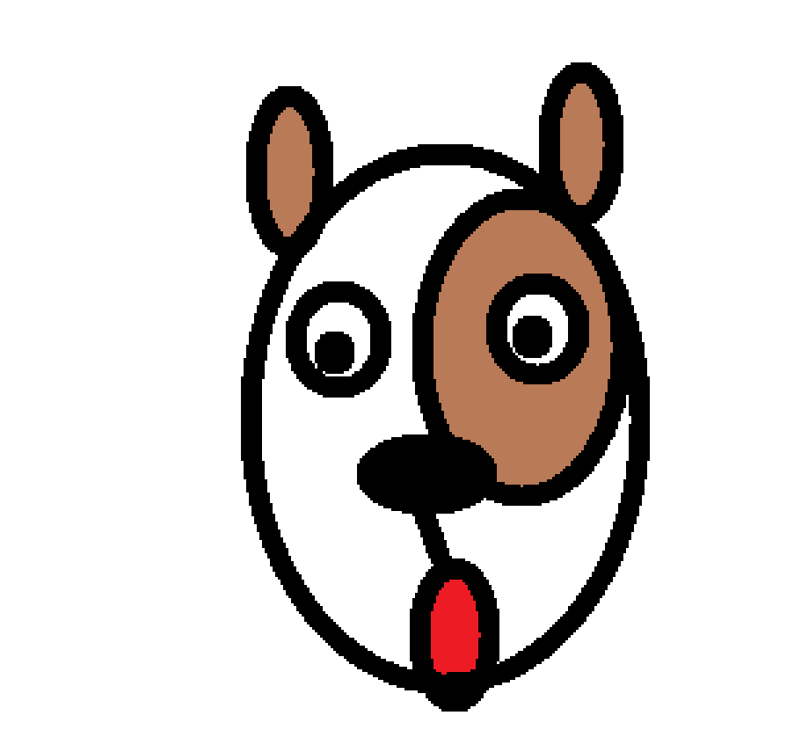

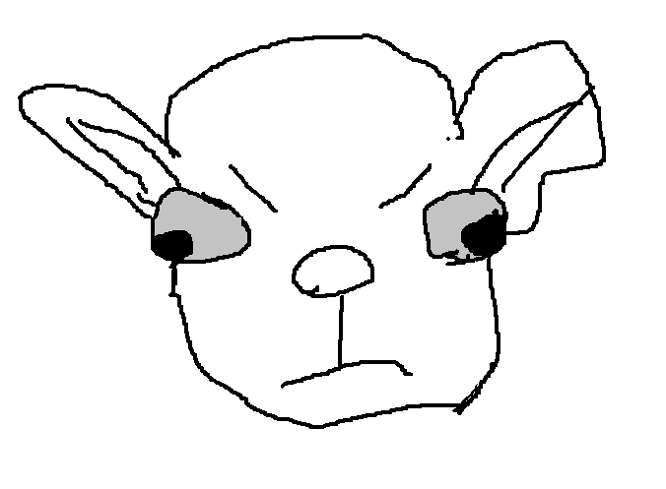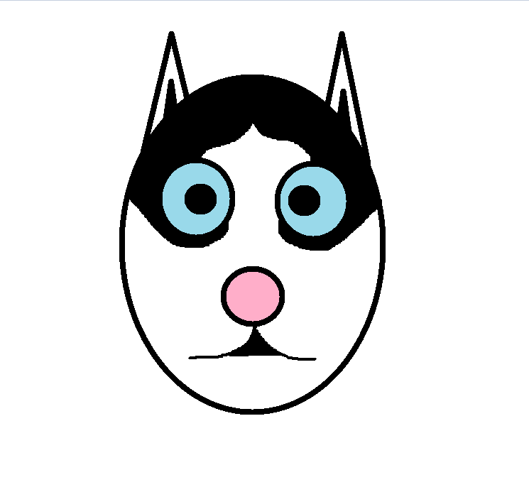

## Publish your game

**發佈你的遊戲**

Your game is ready to be released into the wild. Good luck and congratulations!

你的遊戲已準備好要發佈。恭喜並祝你好運！

Visit developer.amazon.com and follow these steps:

1. Log in and create a new app
2. Enter a description
3. Enter a price
4. Upload screenshots
5. Upload your APK
6. Publish your game!

訪問developer.amazon.com並按照以下步驟操作：

1.登錄並創建一個新的應用程序

2.輸入說明

3.輸入價格

4.上傳螢幕截圖

5.上傳APK

6.發佈你的遊戲！

We love playing new games. Let us know when your game is live by posting a link to it on our Facebook wall at fb.com/AmazonAppDev or Tweet to us @amazonappdev. Be sure to let others know that you used this notebook to help design your game by following the steps on the next page.

我們喜歡玩新遊戲。通過在fb.com/AmazonAppDev上的Facebook牆上發佈連接，或者發送給我們@amazonappdev，讓我們知道您的遊戲何時開放。請務必讓其他人知道您使用此筆記本通過執行下一頁中的步驟來幫助您設計遊戲。